AWS S3, Lambda & SNS to Setup Event-driven Messaging Service

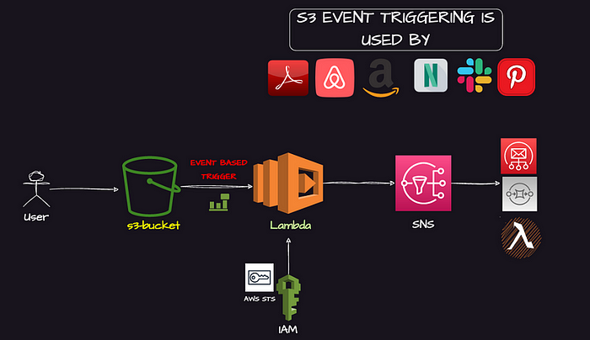

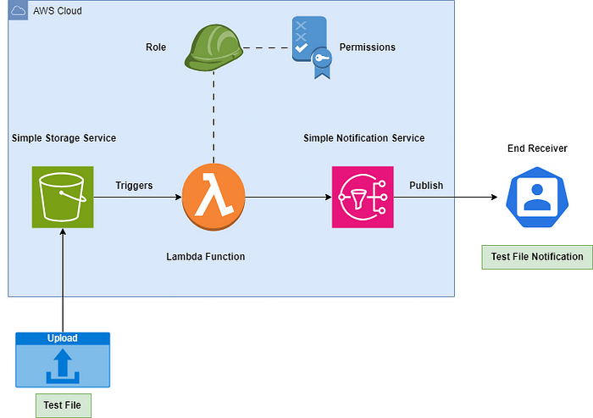

This Event-driven architecture is triggered from S3, captured by a Lambda function, and then passed to Amazon SNS, which sends emails to the customers.

Scenario:
You are running a video-sharing platform similar to YouTube, where users upload videos. Every time a video is uploaded, the platform automatically generates video thumbnails and notifies the content creator (user) when the thumbnail is ready.
Amazon S3: is an object storage service, it is designed to store and retrieve large amounts of data, such as files, documents, images, videos, and backups, in a highly scalable and durable manner.
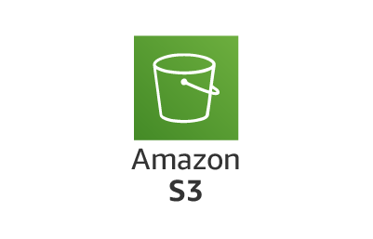

AWS Lambda: is a Serverless computing service, it allows you to run your code without provisioning or managing servers. With this you can focus on writing and deploying code while AWS takes care of the underlying infrastructure and scaling.



AWS SNS (Simple Notification Service): is a fully managed messaging service, it enables you to send notifications to various endpoints.

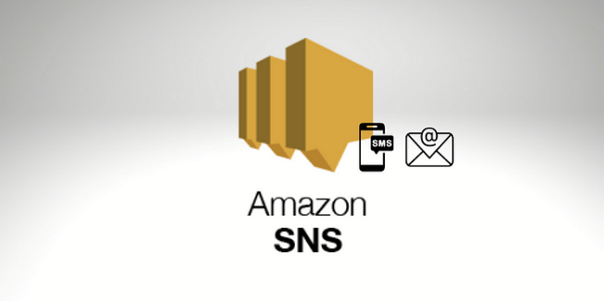
Steps:
- Create an S3 bucket (event-lambda-projects) – disable encryption - create
- Create a topic in SNS services – standard – (myeventopic) – create subscription – give the email – manually verify
- Create lambda function (mylambdafunction) – runtime (python) chooses the latest one – create function
- Next, click on test, where we are going to create an event (myemailtest) – save
- Now, come back to code – and copy paste the code [make sure to edit the SNS ARN accordingly], then click on deploy; once it got deployed; now click on “test” and choose the event which we created earlier (myemailtest) – and check the output for the same. [we will get the error msg here, as we haven’t attached the permissions, so next we need to attach the permission accordingly]
import json
import boto3

def lambda_handler(event, context):
sns_client = boto3.client('sns')
topic_arn = 'arn:aws:sns:us-east-2:975050243542:myeventopic'

# Parse the S3 event
for record in event['Records']:
bucket = record['s3']['bucket']['name']
key = record['s3']['object']['key']
message = f'Image uploaded to bucket {bucket} with key {key}'

# Publish message to SNS
sns_client.publish(
TopicArn=topic_arn,
Message=message,
Subject='Integration Notification'
)

return {
'statusCode': 200,
'body': json.dumps('Notification sent successfully!')
}

- Let us try to integrate lambda function into the S3 service, [2 options are there
- go inside the created bucket and go to the properties option and scroll down, click on create event notification, give the name (myeventproject) – under event types (put) – under Destination, make sure Lambda function, and choose the Lambda function (mylambdafunction) – save
- Come to lambda, click on add trigger, select S3 – choose the bucket – leave everything default, acknowledge & add]

- Come to Lambda, refresh and we can see that S3 has been integrated successfully, that means as soon as we upload something in S3 bucket, Lambda function will trigger or automatically run.
- But, if we are trying to execute anything it is not going to trigger anything as we don’t have enough connection inbetween S3 and SNS, so to provide this, click on the configuration which you can see on the lambda area – choose permissions – click on the role name (this redirects us to the IAM Roles area) – let us add the full access permission for the lambda event for (S3FullAccess & SNSFullAccess) – Add
- Now, upload anything inside the S3 bucket and this is going to send us with the confirmation/trigger the notification for the same.

Deletion Process:
- Delete the S3 bucket & object
- Delete the SNS topic along with the subscription
- Delete the Lambda function
- Delete the IAM Role that was created
- Delete the log from cloudwatch – log group

